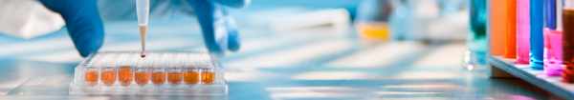
Scientific laboratory “Bionanocomposite”
As a student of Biomedical Engineering, you’ll have many opportunities to improve your understanding of your field through hands-on research in one of our state-of-the-art laboratories.
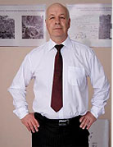
The supervisor of the laboratory is the head of the department of Biophysics, Biochemistry, Pharmacology and Biomolecular Engineering - Corresponding Member of NAS of Ukraine, Professor Leonid Fedorovich Sukhodub.

The Bionanocomposite Laboratory contains equipment for the manufacture of new hybrid biomaterials, coatings and constructs from polymers and ceramics (in particular, calcium orthophosphates), which are designed for regeneration therapy to treat tissue damage or loss in various parts of the body (bones, nerves, external tissues).
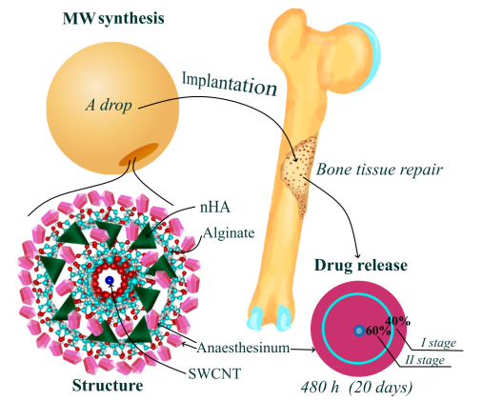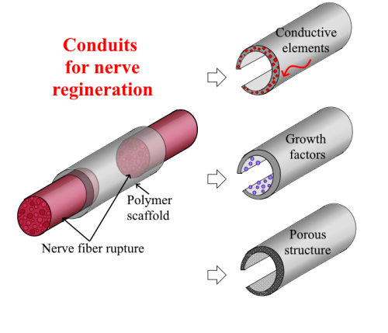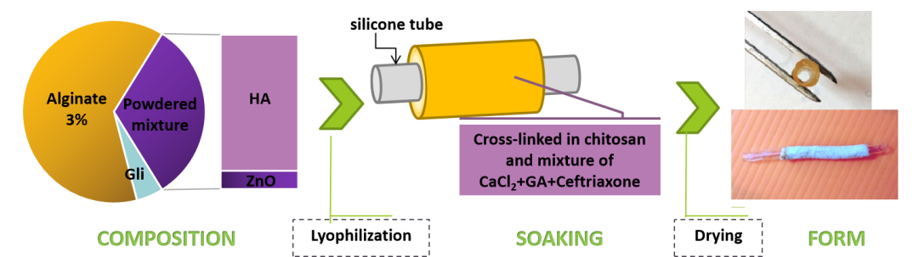
Drainages
Drug
delivery
systems
In addition, laboratory focused on development of polymer drug carriers and novel therapeutic strategies and application of biomaterials to biological systems – conduits to repair nerve damage, drainages for treatment of purulent and biocompatible nanomaterials for drug delivery and controlled release of drugs for chronic diseases.
The manufacturing facilities in this laboratory allow fabrication of materials and constructs using a range of processing techniques such as solvent-based, coating-based approaches.
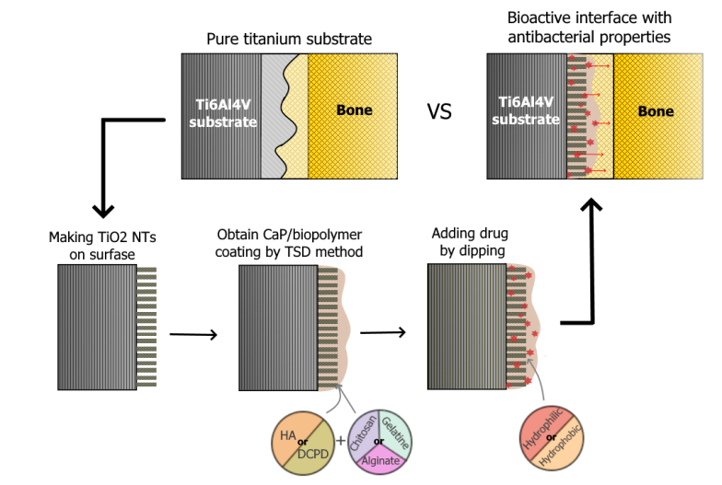
Substrates
The laboratory is equipped with X-ray fluorescence analysis ElvaX Light SDD, High performance liquid chromatograph Agilent Technologies 1200. It is possible to book the laboratory equipment to conduct individual research.
Follow link: https://sumdu.edu.ua/uk/science/science-info/scientific-infrastructure/scientific-centers-collective-use/ccse.html
Address:
2, Rymskogo-Korsakova st., 40007 Sumy, Ukraine
Central building, room 206
Tel. +38(0542)68-78-72, +38(0542)687734.
e-mail: l_sukhodub@yahoo.com

